How to borrow from the school library

- Log in to your school portal through the DET login page, using your student login.

https://portal.det.nsw.edu.au/

- Click on the ‘Oliver library’ icon on the left hand side of the page.
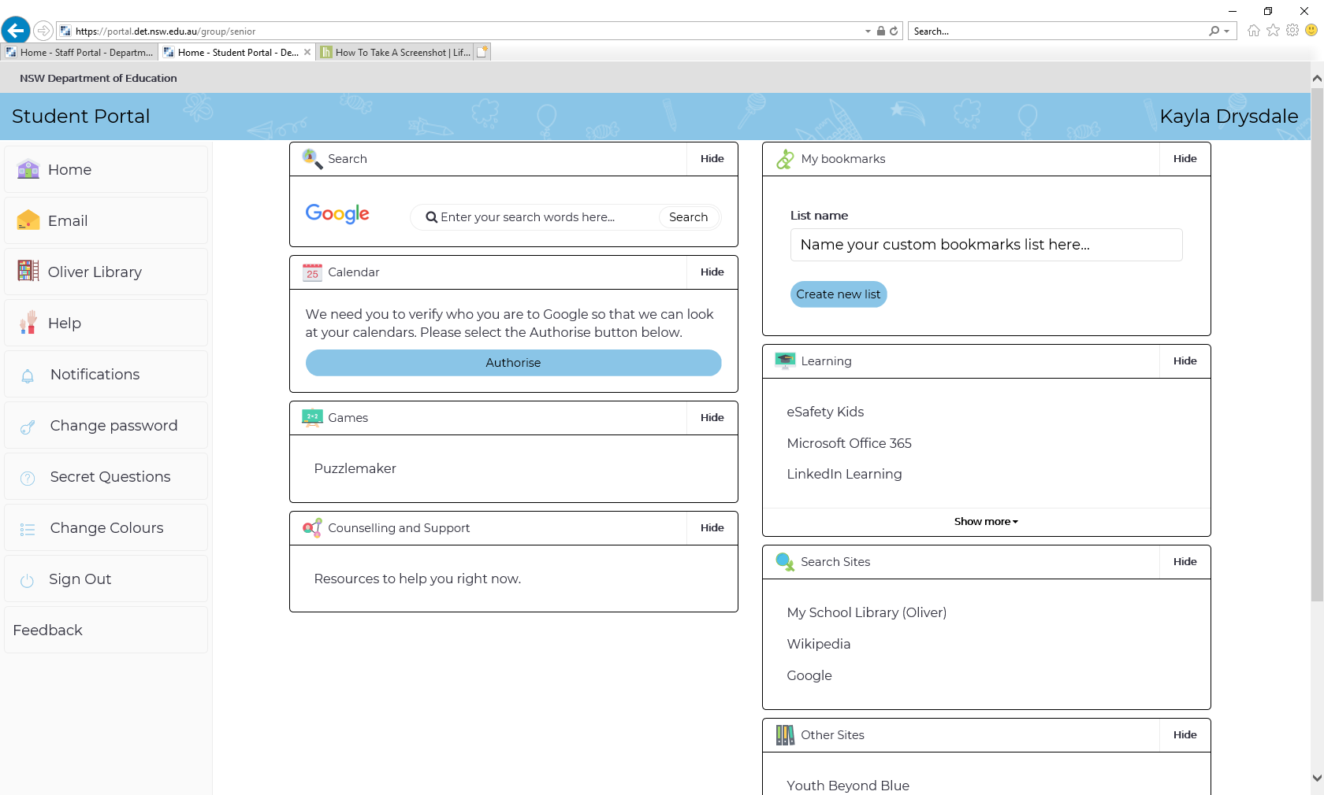

- Search for authors or books or look at the books available in the library displayed on your page.
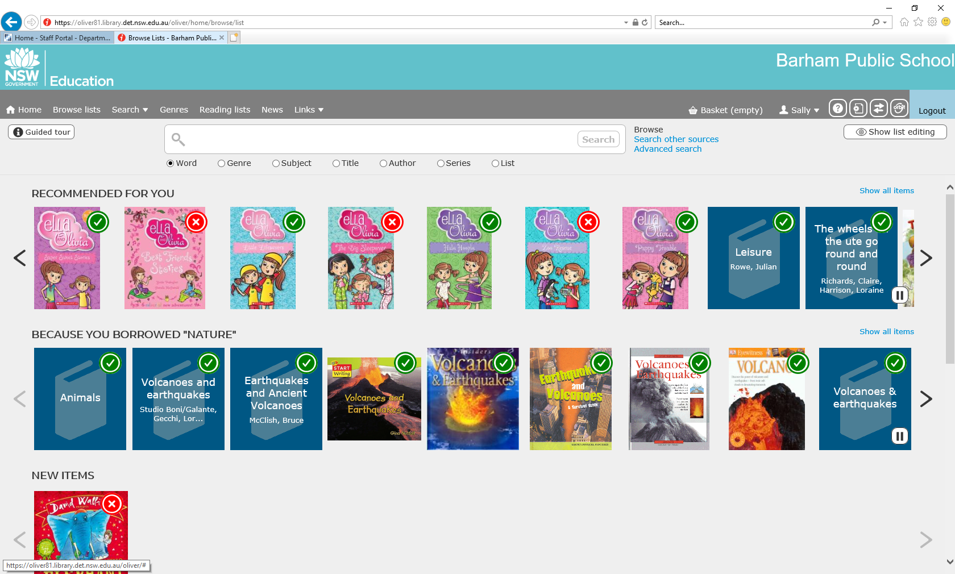
CLICK THE ARROW FOR MORE BOOK SUGGESTIONS
ENTER SEARCH ITEM HERE

- You can also use ‘Orbit’ (top right hand corner) to look for books about specific or different topics.

- When in Orbit, use ‘pick and click’ to search for books about particular subjects.
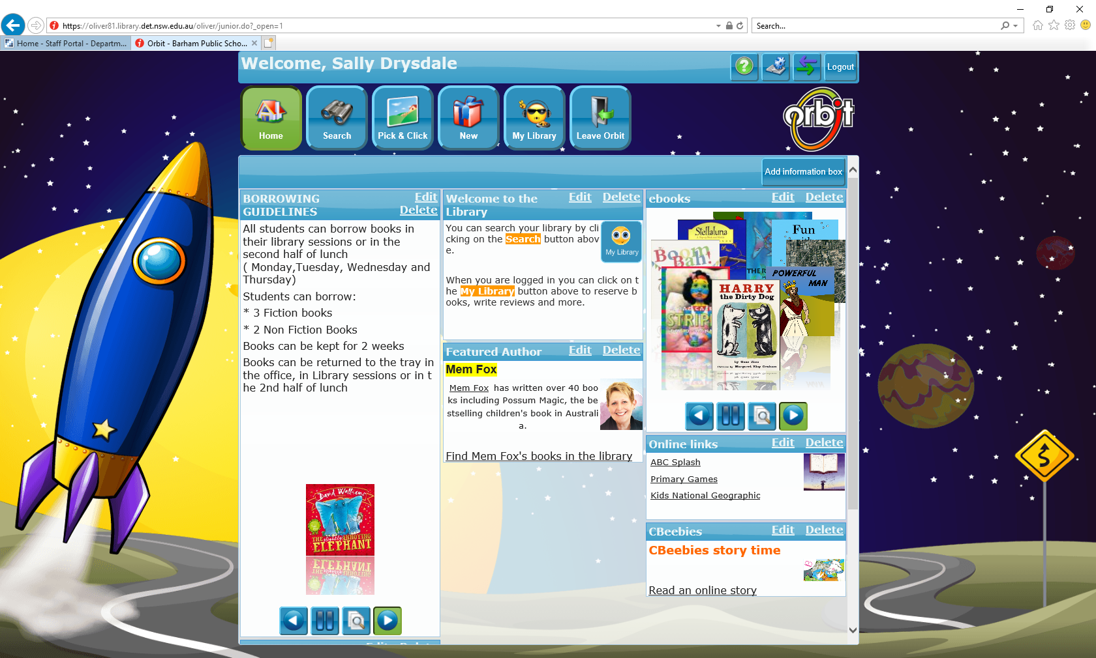
- When you have found a book you want to borrow, click on the picture of the book. This will bring up more detailed information about the book.

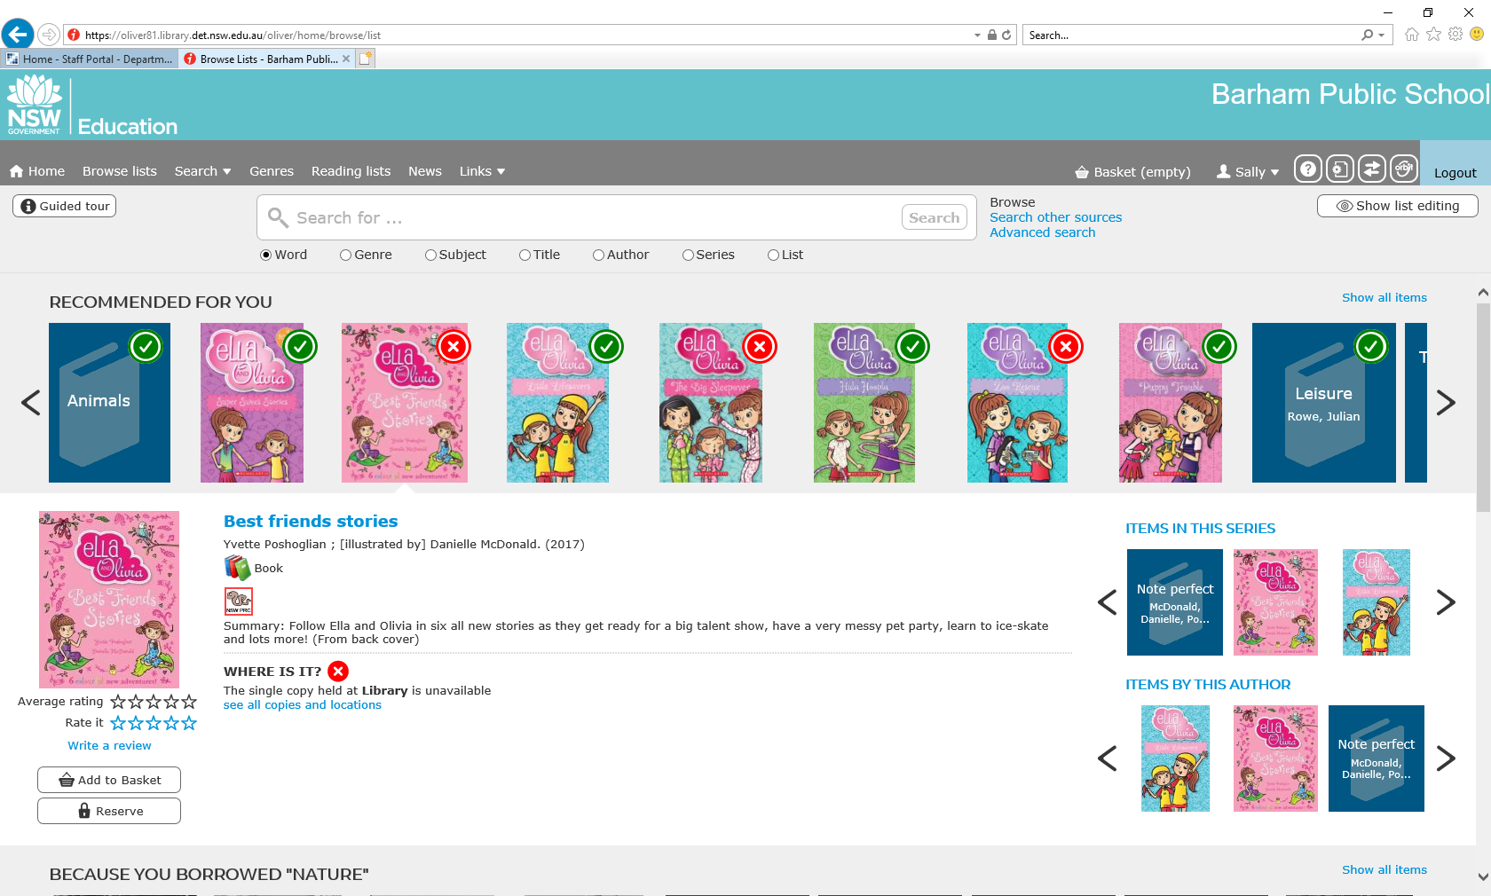

- Click on ‘reserve’ on the left hand side of the screen.

- A confirmation box will pop up. Click ‘reserve’ again.
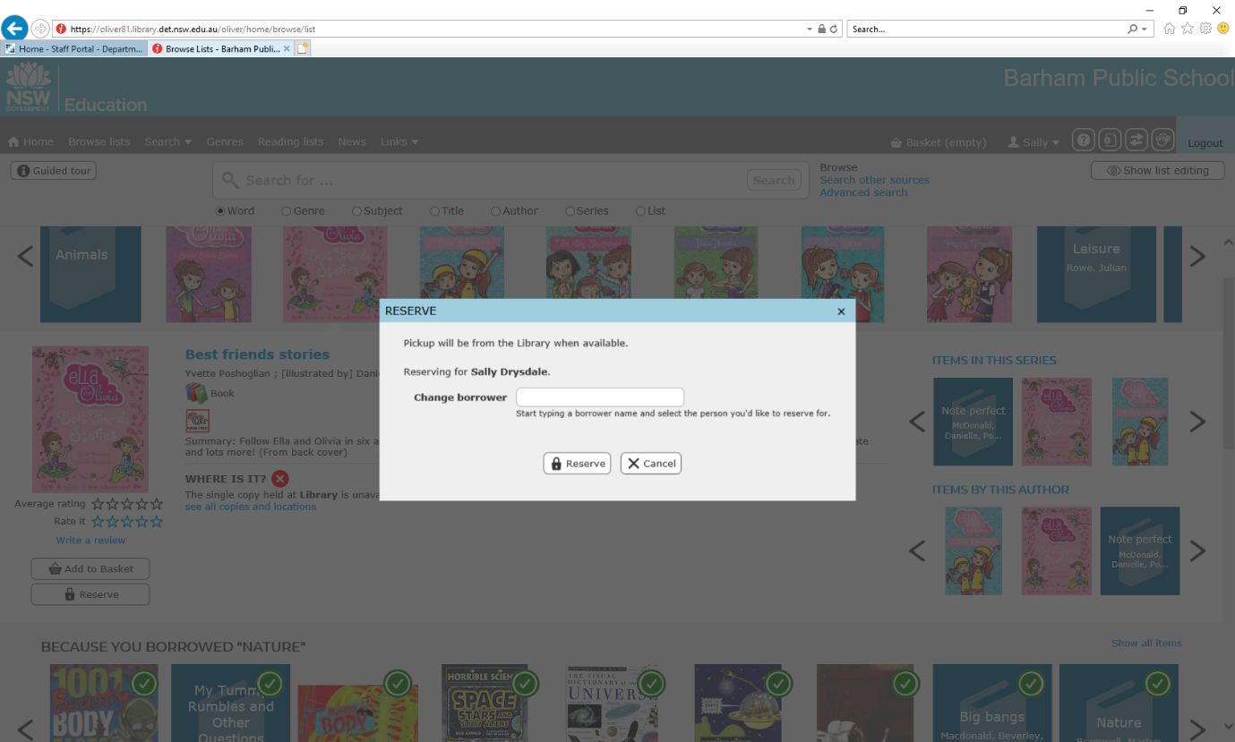

- Your books will be available for collection on XXXXXXXXXXXX

* Please note
Books marked with a red X are currently on loan to another student. You are still able to reserve these books, however in the event they are not returned in time, it is suggested that you reserve more than one book.

Premiers Reading Challenge books:

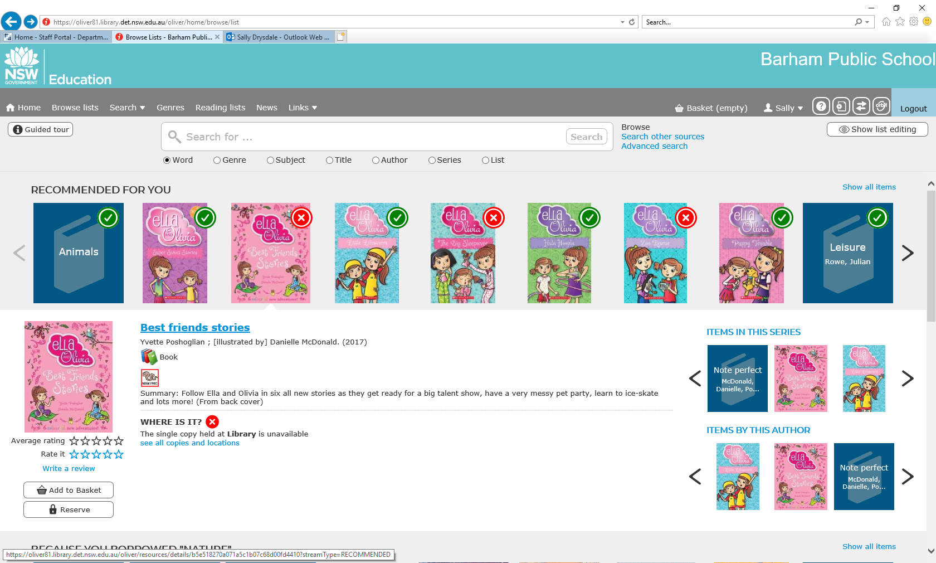
- Books that are on the PRC list will display this icon:

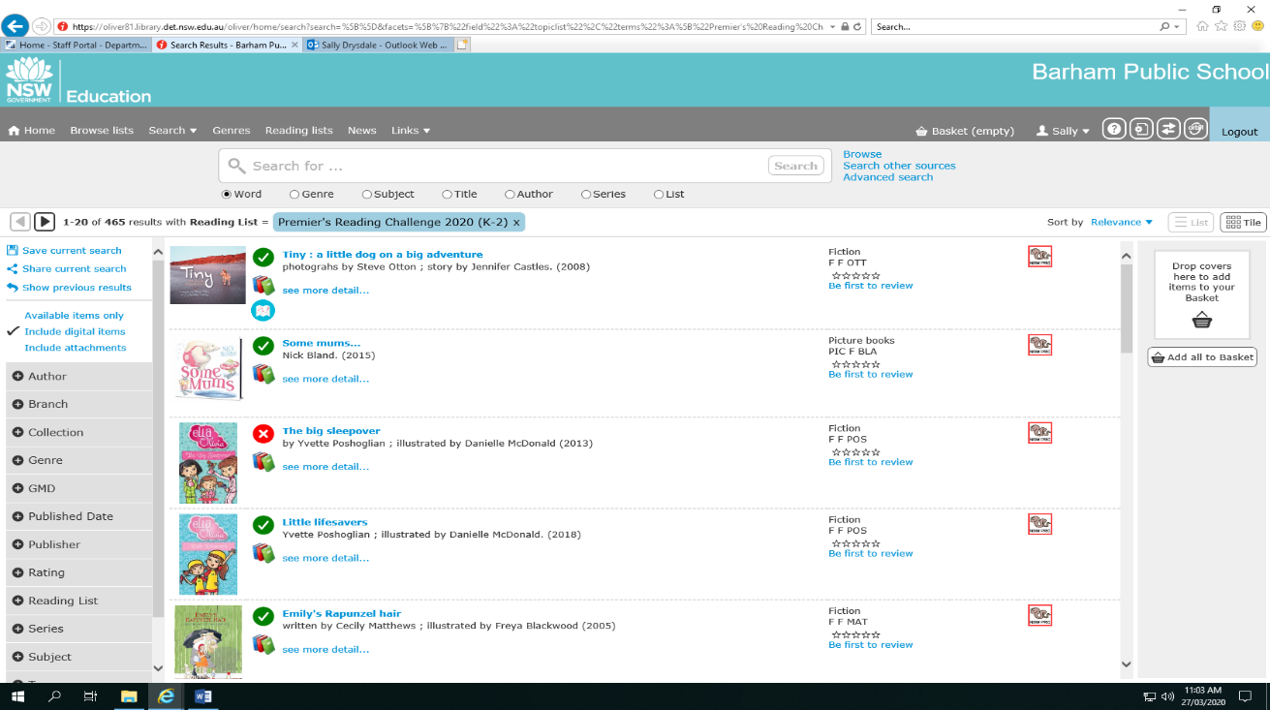
- If you click on the icon, Oliver will display a list of PRC books for that year level.
The coloured icons represent the following year levels:
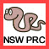
- K-2

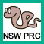
- 3-4

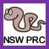
- 5-6

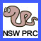

- 7-9

