How do I access Soundwaves online activities?
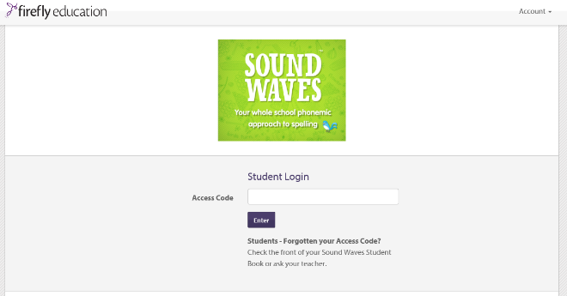
- Students access www.soundwaveskids.com.au and type in their year level code.
All year level codes are on the following page.

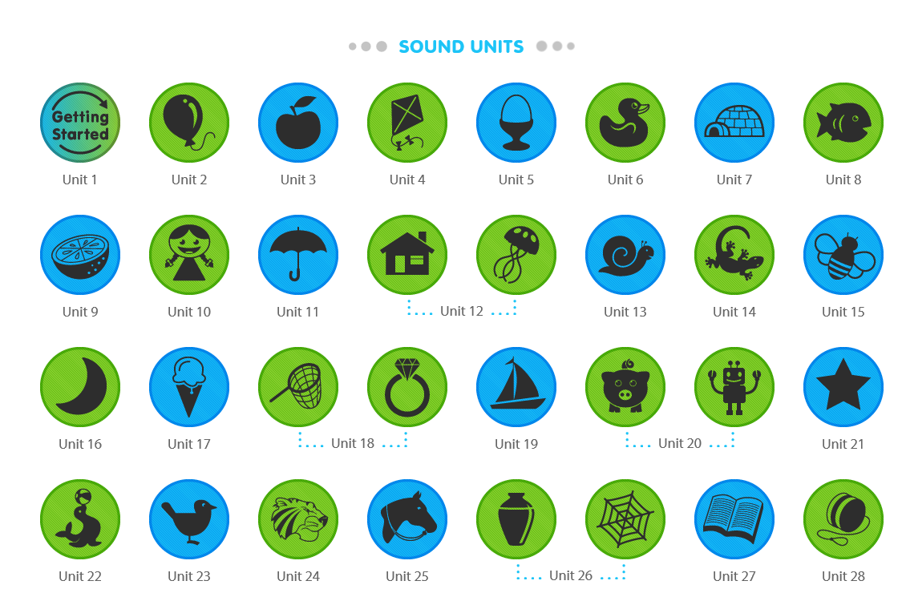
- Select or find the sound unit you are working on. (For example if you are working on the ‘g’ sound, find the girl icon and select Unit 10)

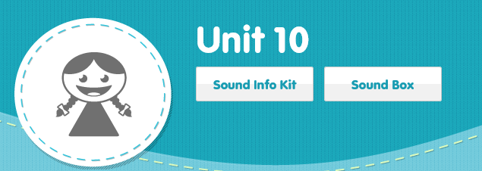
- Sound Info Kit will take you to a page in which someone will make the sound and explain how to do it.

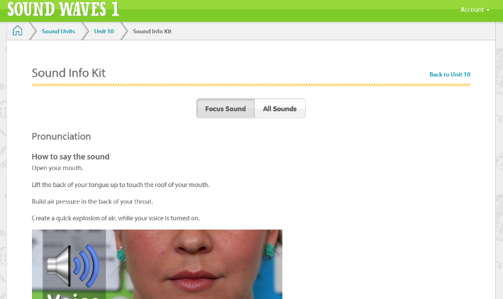
- You can go back to any of the previous pages by selecting from the top options bar.
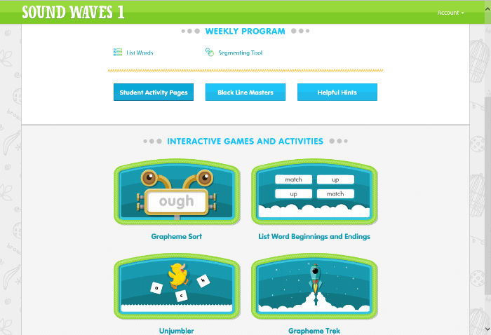
- The unit page allows you to select different activities for students to access.
You can choose from using the segmenting tool and completing interactive games and activities in order to apply your knowledge of the sounds you are working on.

Student Access Codes

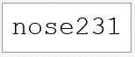
Kindergarten

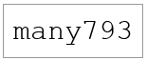
Grade 1

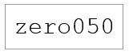
Grade 2

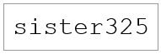
Grade 3

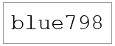
Grade 4

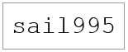
Grade 5

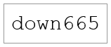
Grade 6

