How do I access Studyladder online activities?
- Some web browsers cannot access games/activities. It is reccomended to use Google Chrome.
- Students access https://www.studyladder.com.au/ and press the log in box in the top right hand corner.
Students then enter their username and password. If you are unsure of your username and password, contact your teacher.
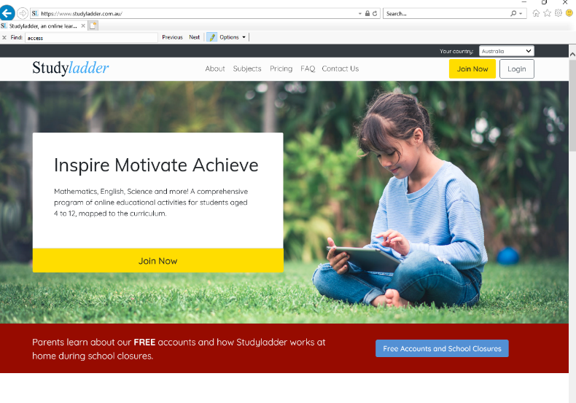

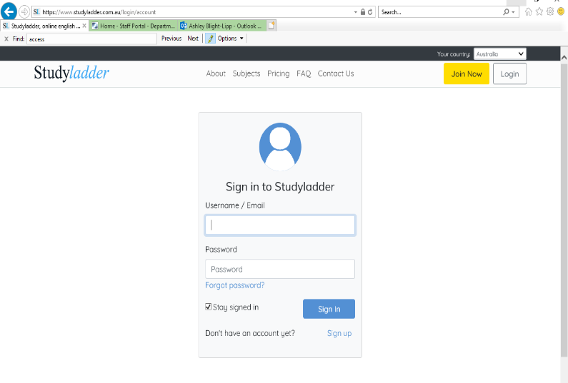

- Select My Individual Program for activities allocated to you by your teacher.
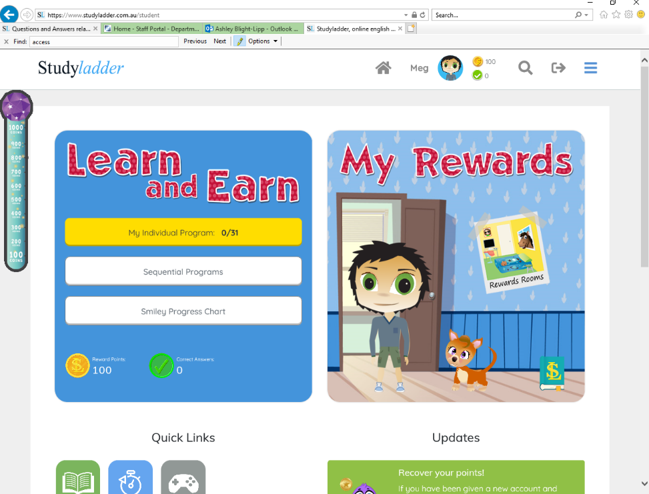

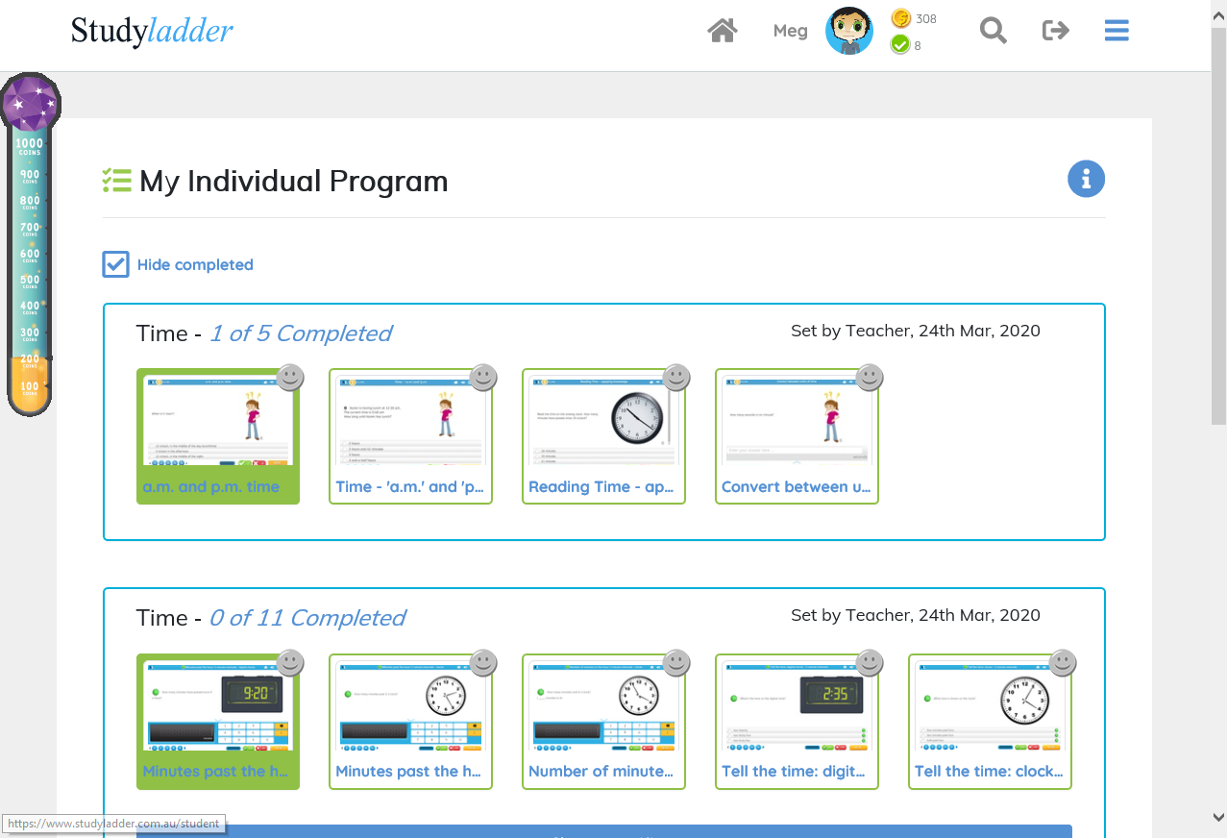

- Select Sequential Programs to work your way down from top to bottom to follow a sequential learning order.

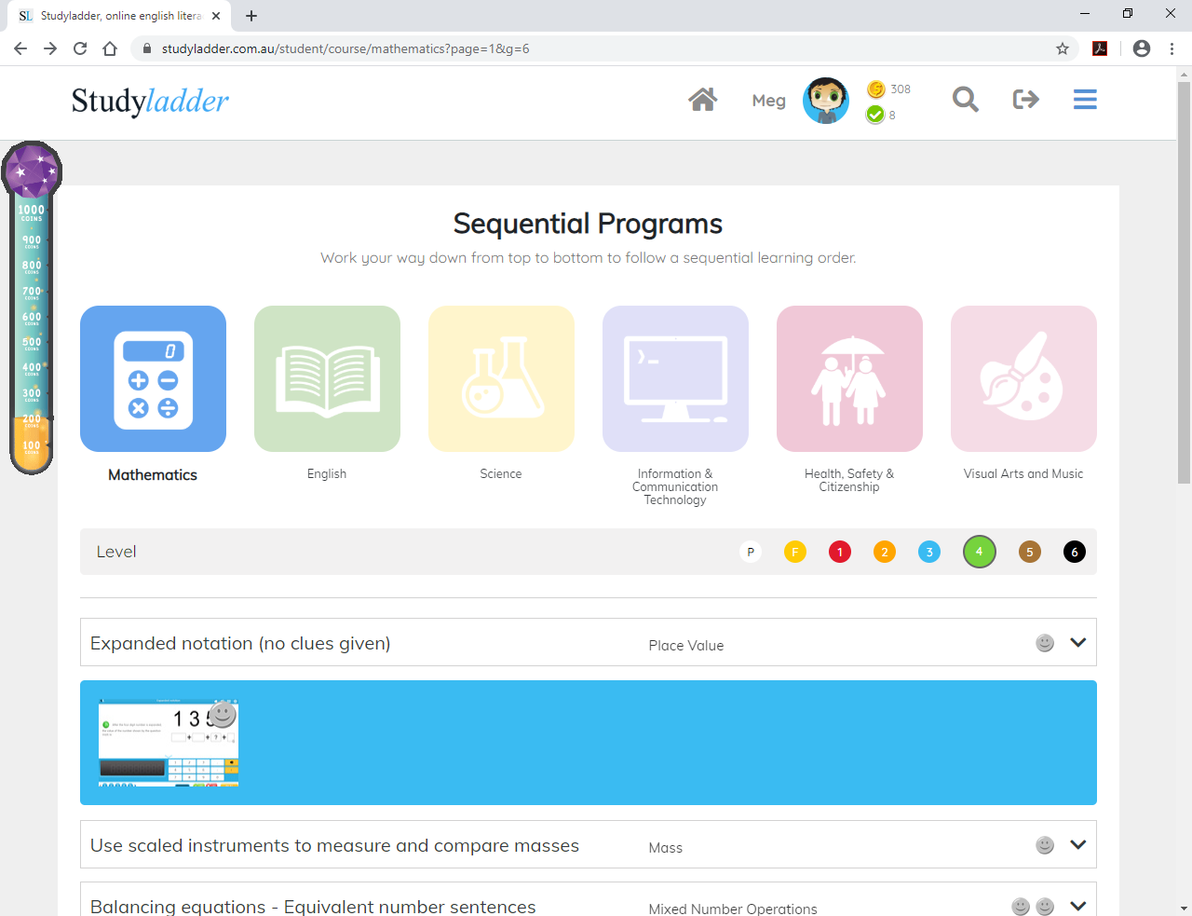

- When you are in an activity, pressing the speaker will read the question for you.
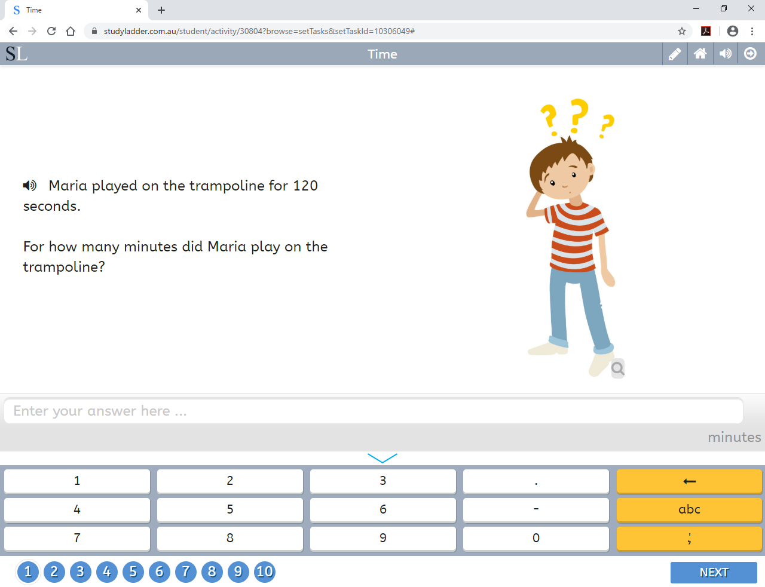
- Pressing the pencil will bring up some working out space for you.

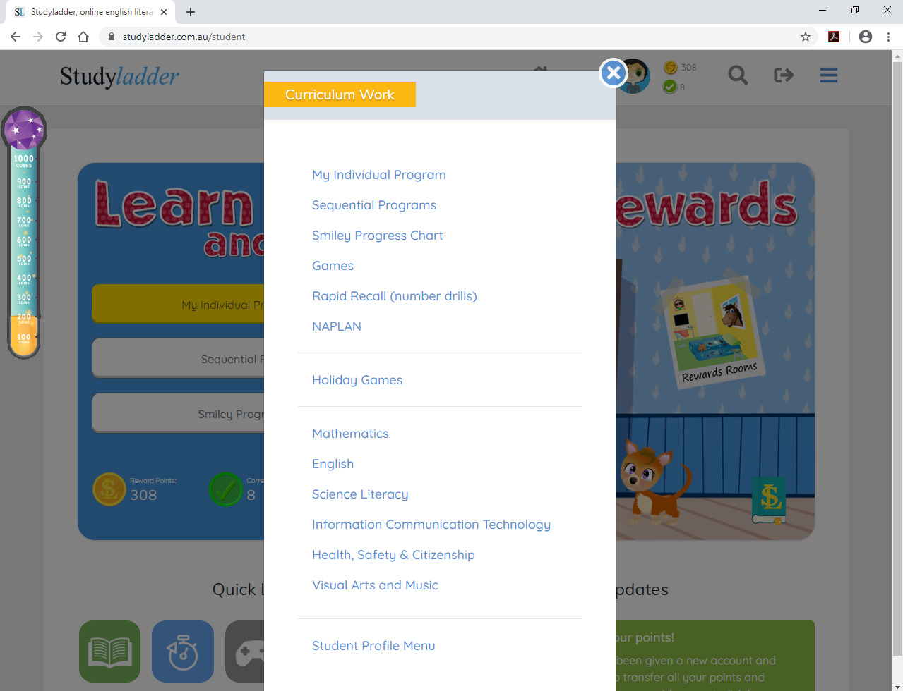
- Other options such as games and number drills are accessible through selecting the menu at the top right-hand corner while on the home page.

