How do I access teams?

- Access the student portal here at https://education.nsw.gov.au/
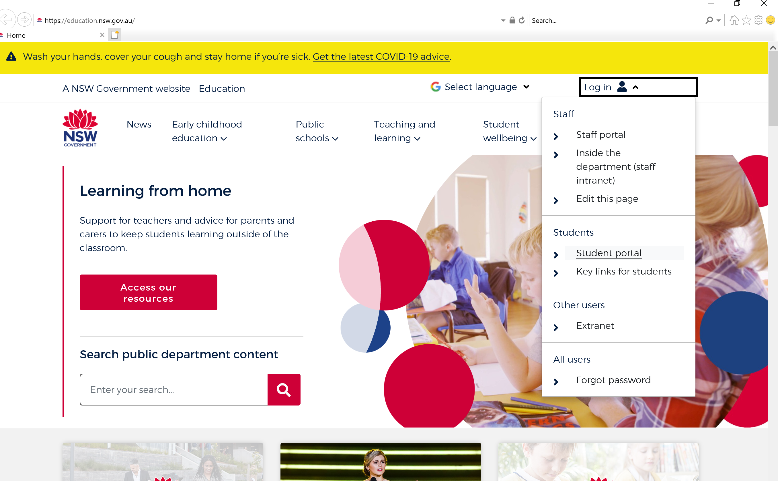

- Go to the Learning Box and click Show more here.
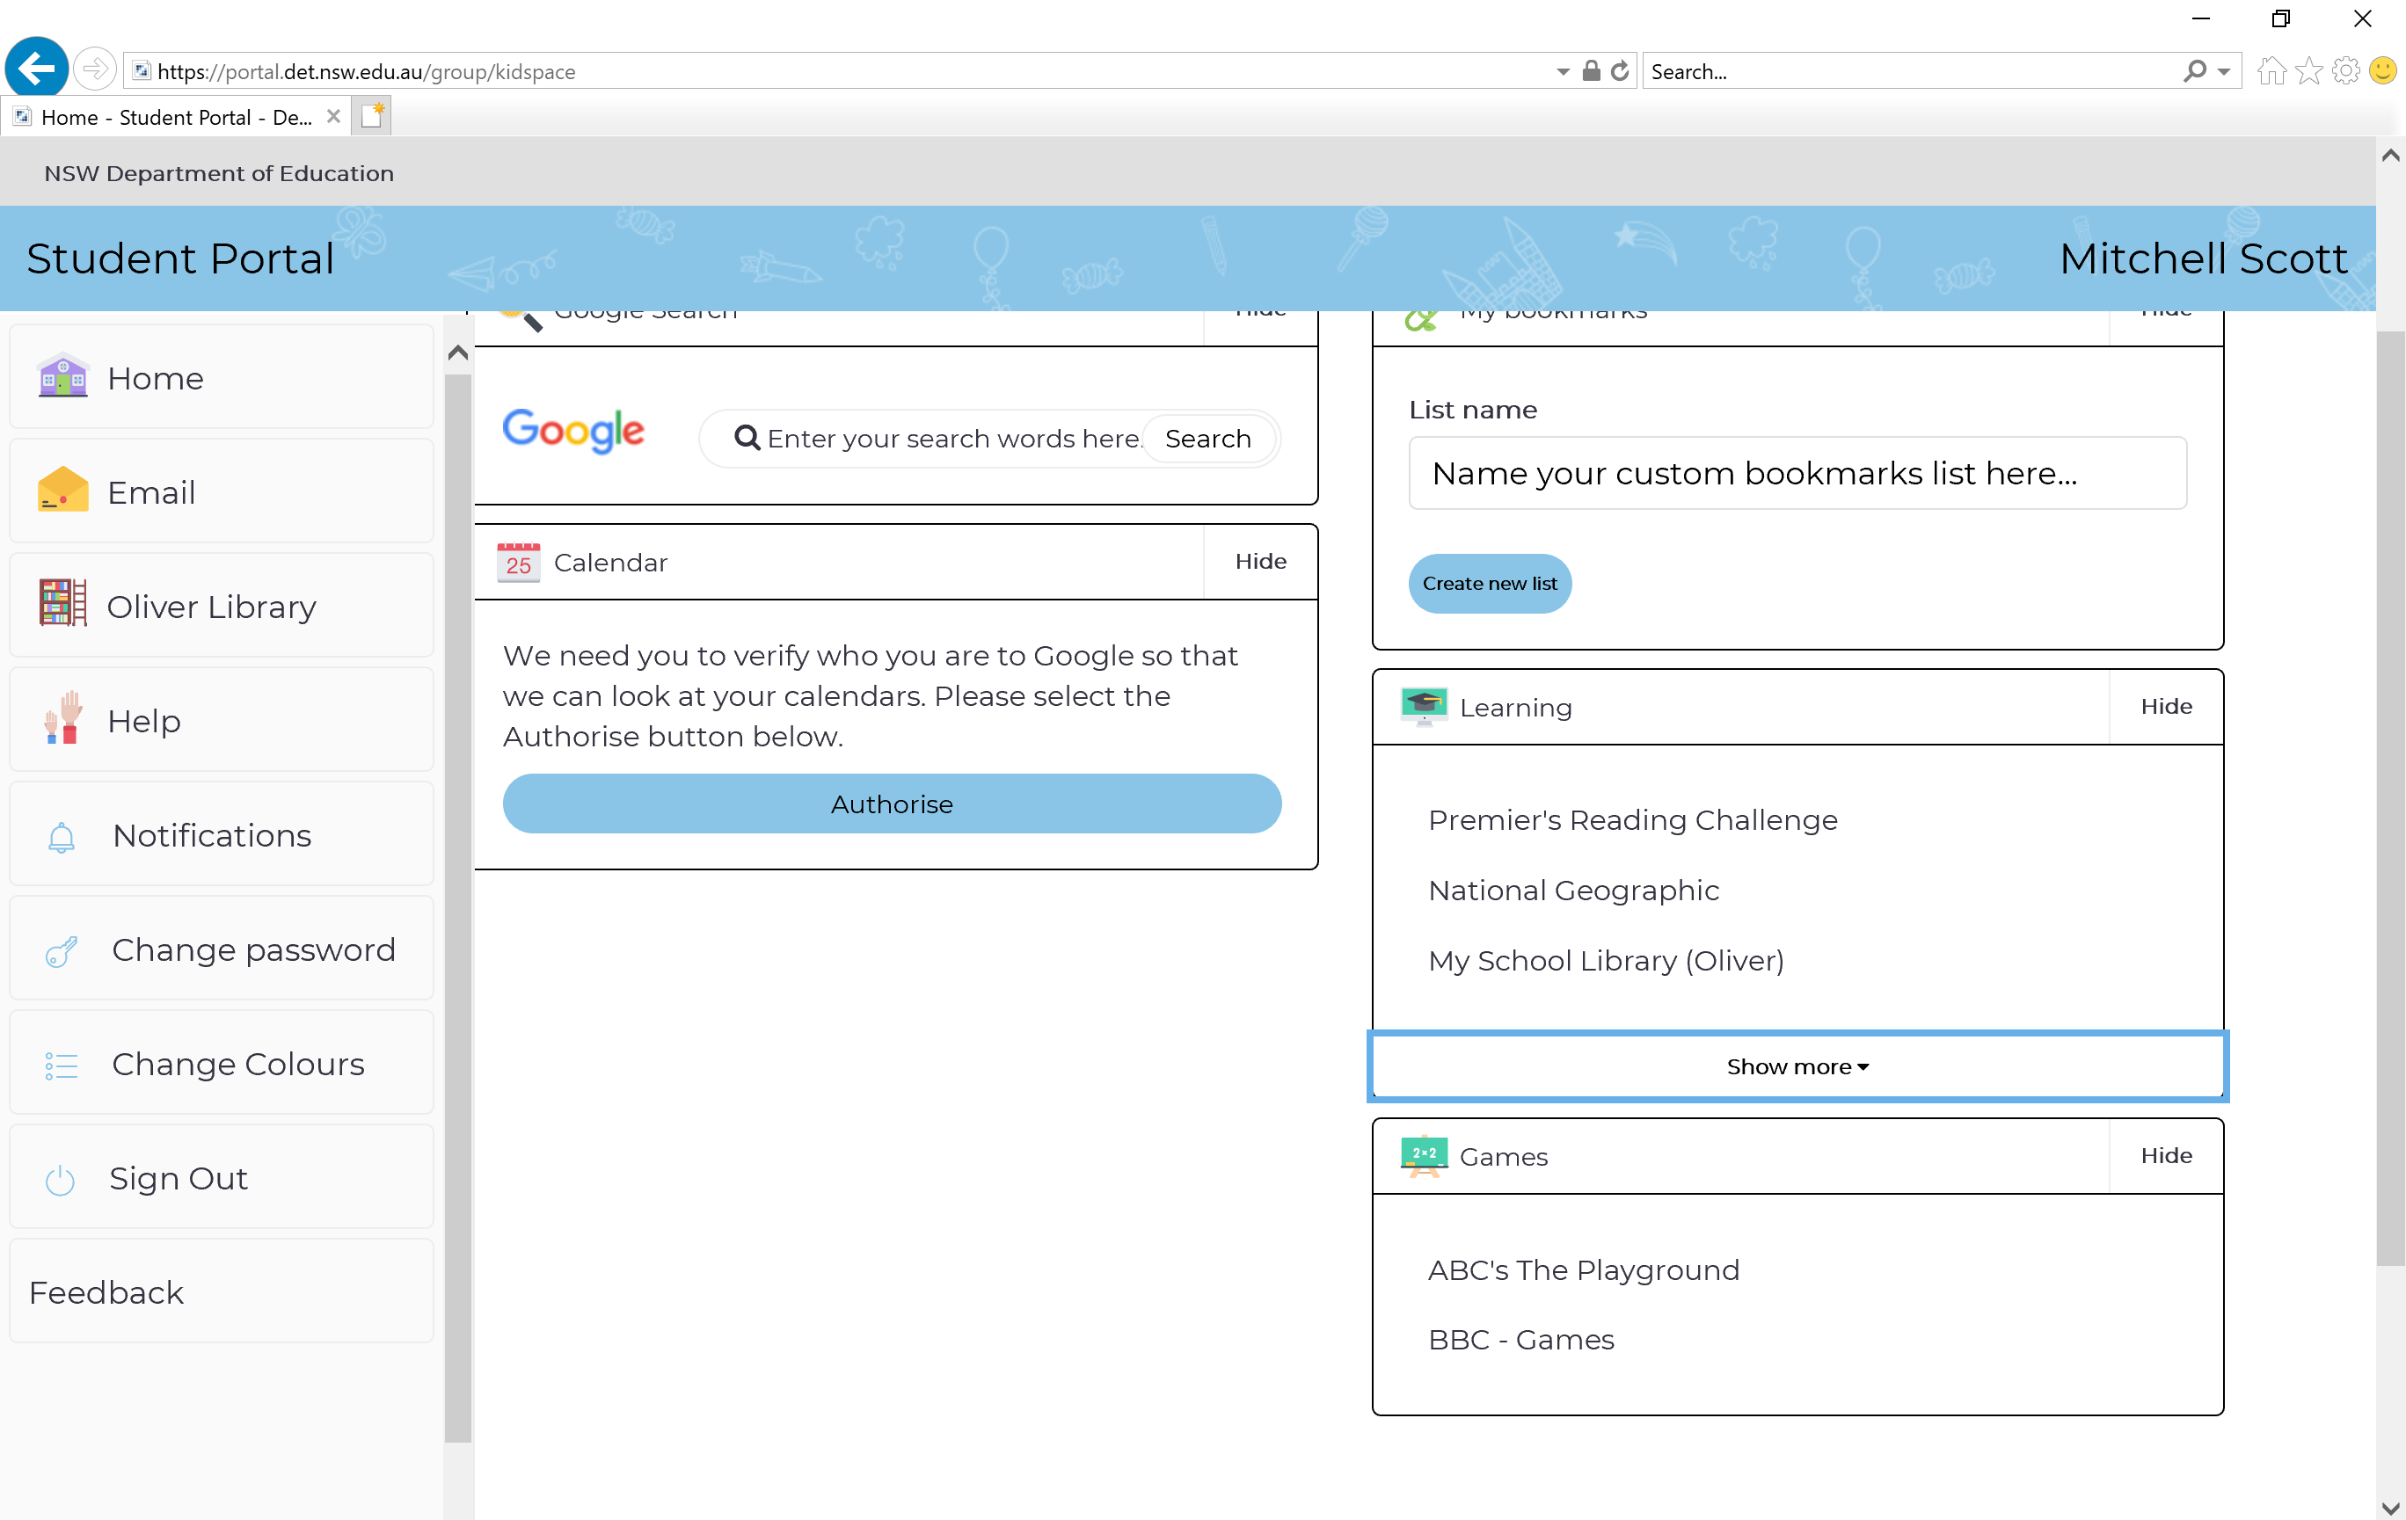
- Click on Microsoft Office 365 here.
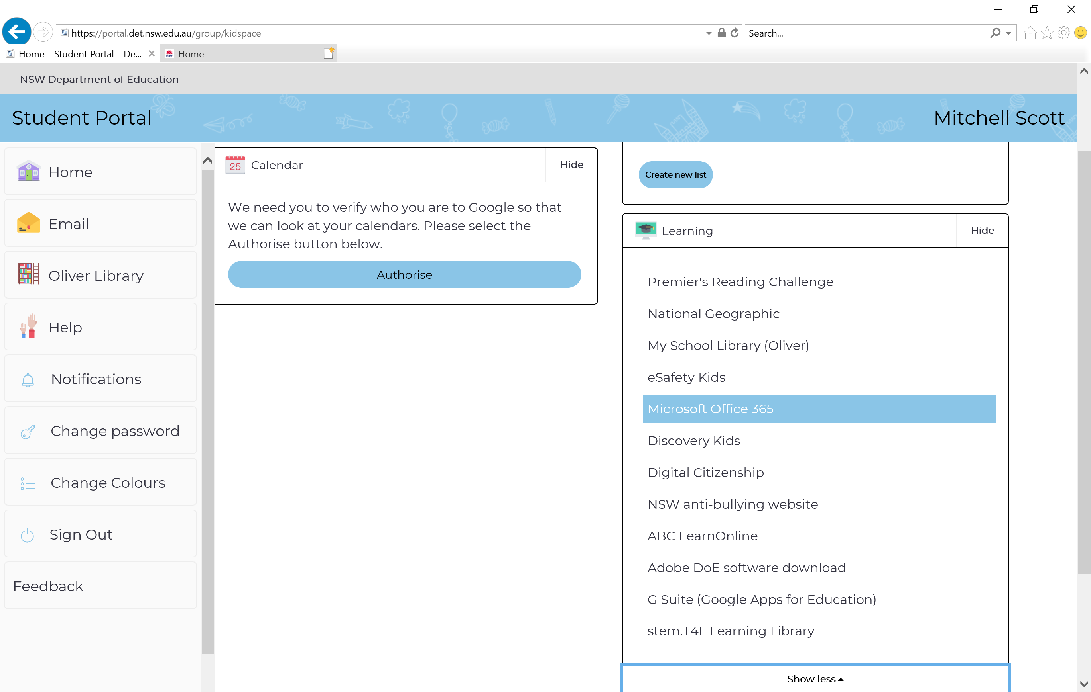
- Click on the Teams icon – it may not be in the exact same place on your screen but the picture will be the same and it will say Teams.
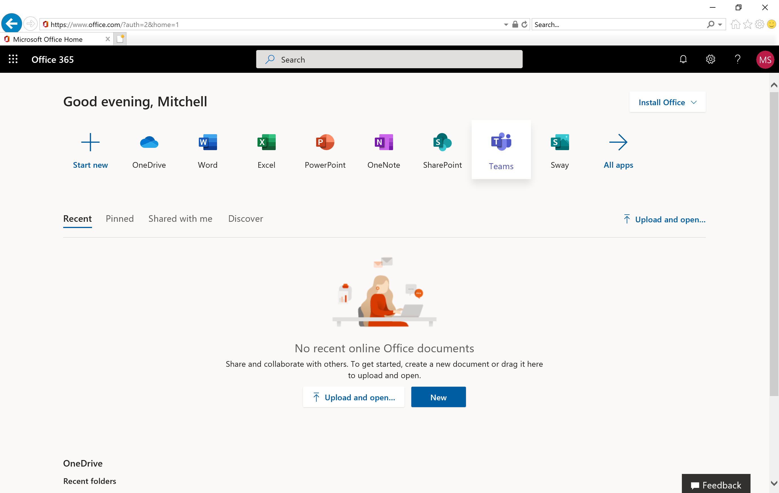
- Click on your class tile.
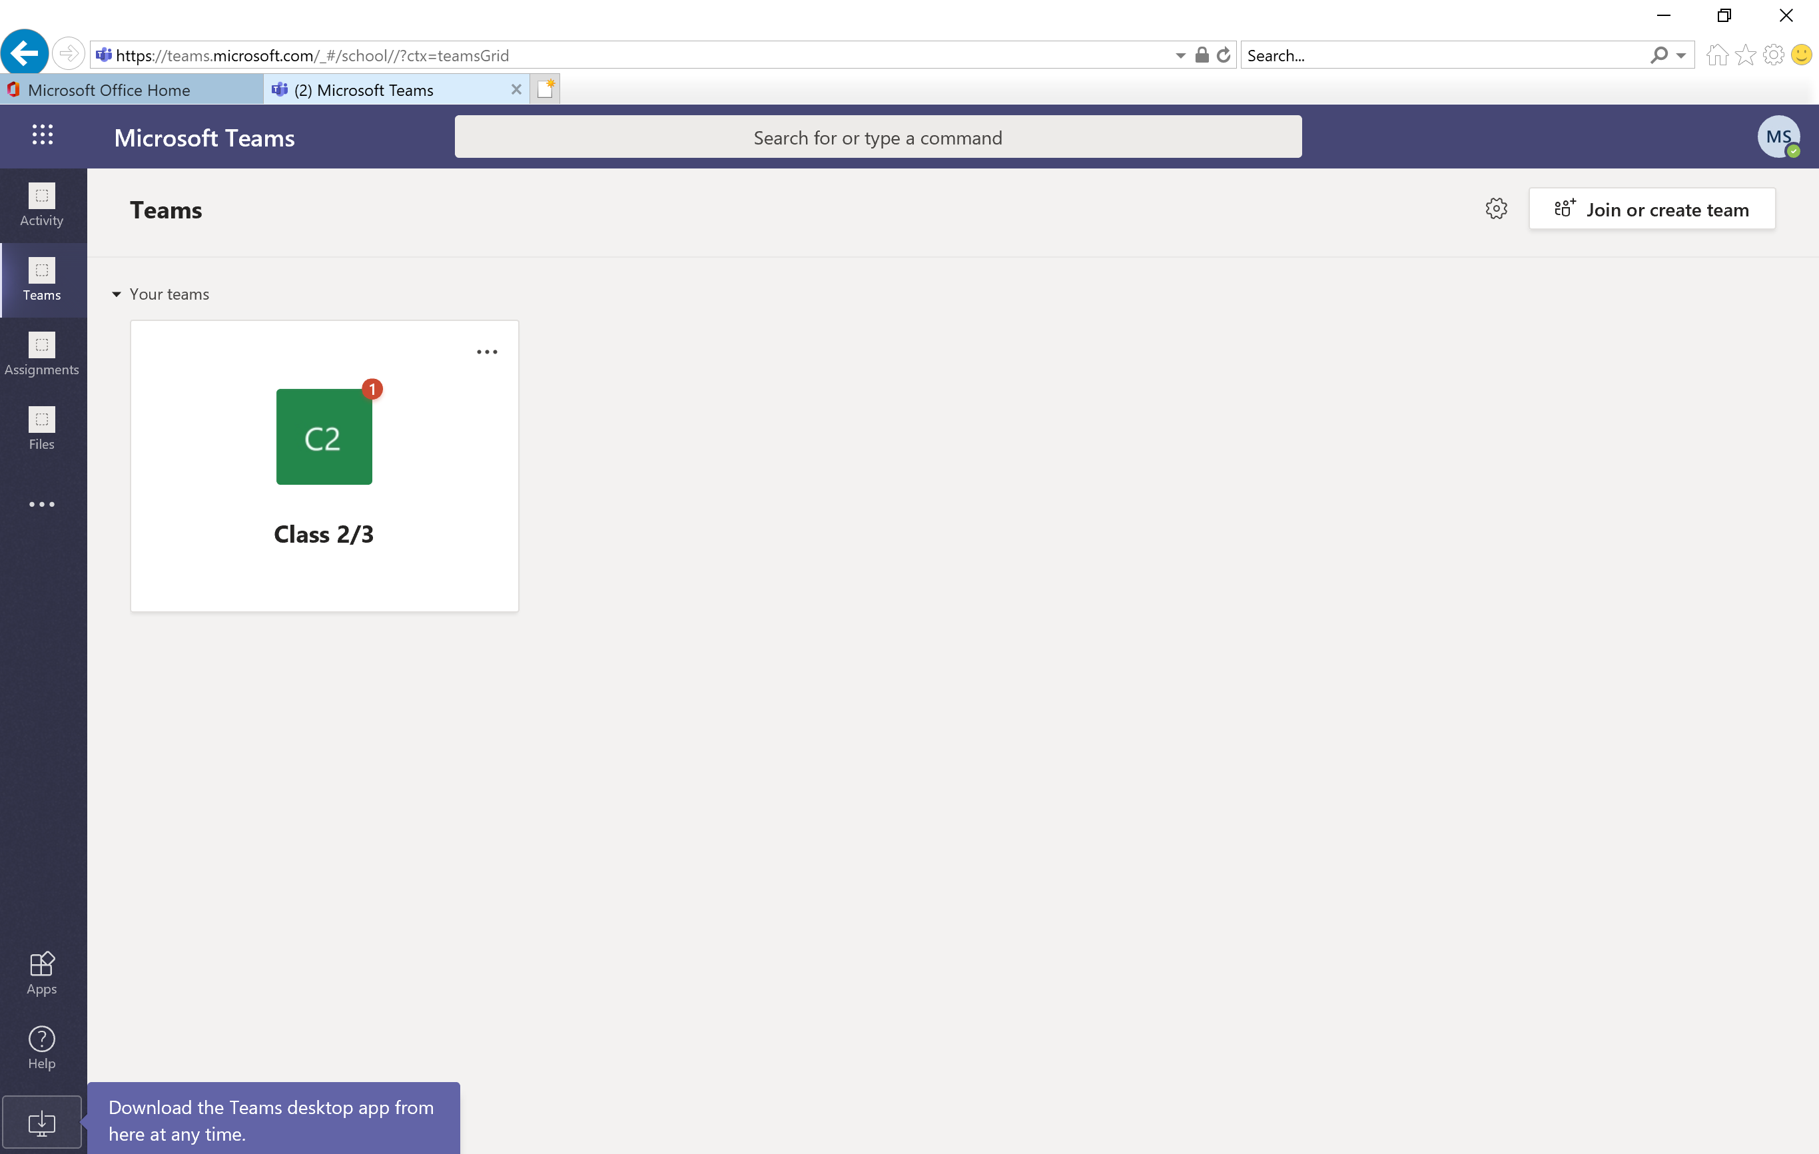
Congratulations, you have now joined your class team!

How do I set up the Teams app?

- You may want to download the Teams app if your device allows it. You would then be able to access teams directly from the app installed on your device. Click here to download the app.
- You may be prompted to log in to the Teams app when you first use it. You will be prompted for your Microsoft account which is the same as your student username followed by ‘@det.nsw.edu.au’ like below.
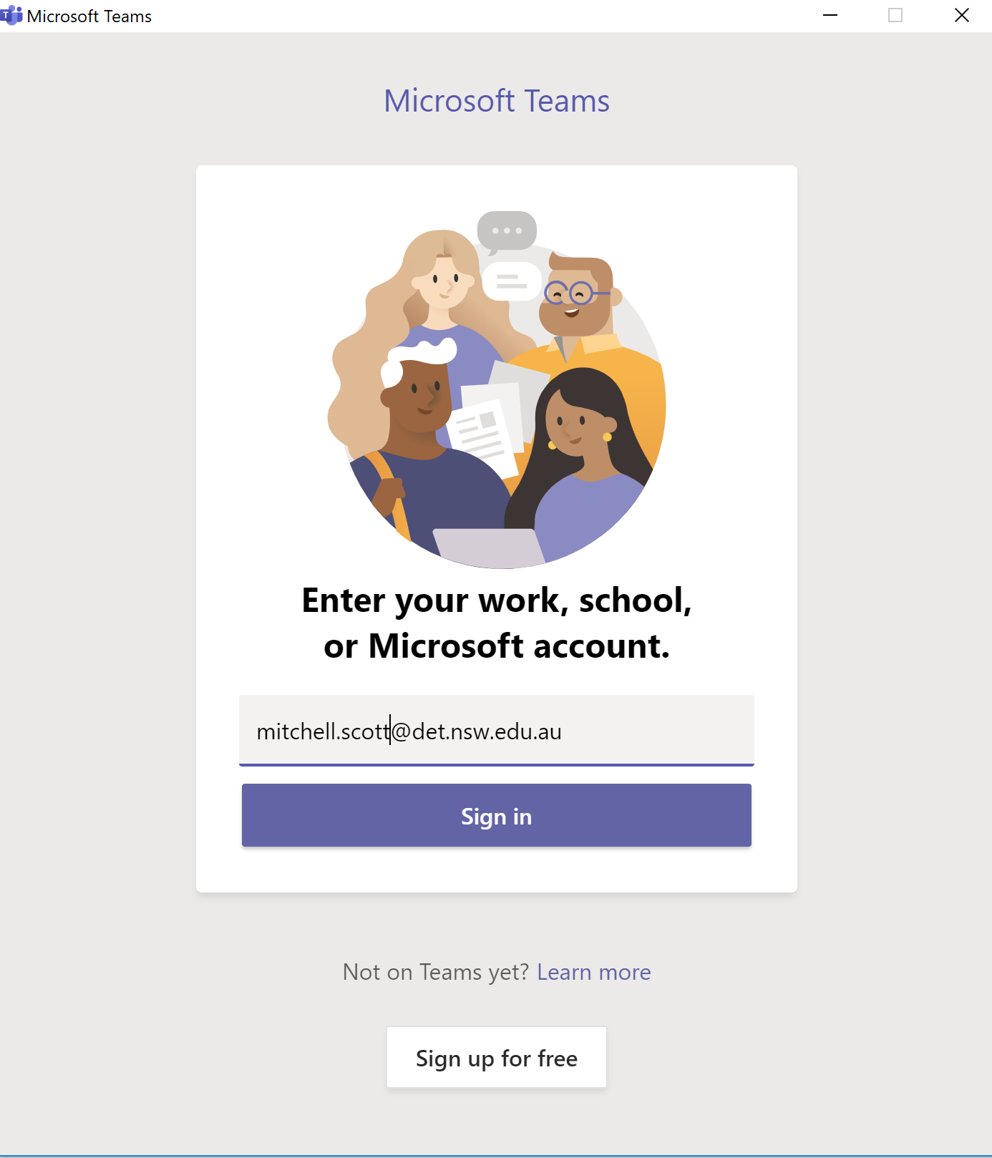
- This will take you to a login page – this page will look just like your student log in page.
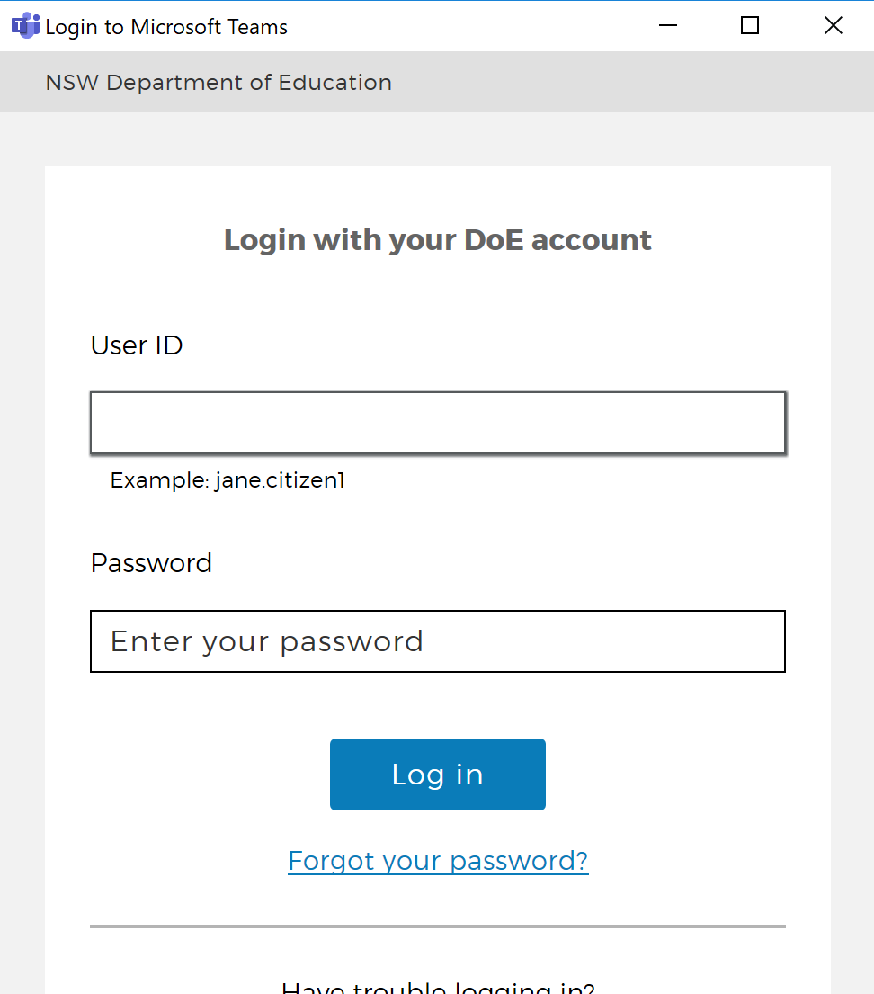
Congratulations, you have set up the Teams app!

