Barham Public School
KINDERGARTEN TRANSITION PROGRAM

Taster sessions in TErm 3

Tuesday 6th August 10.30am – 11.30am: Playground play
Bring a hat and small recess snack.

Tuesday 20th August 10.00am – 11.00am: Library

Friday 23rd August 9.30am: Book Week Parade Come dressed up as your favourite book character. This year’s theme is ‘Reading is my secret power’.

Tuesday 3rd September 10.00am – 11.30am: Kitchen and Garden and recess play. Bring a hat.

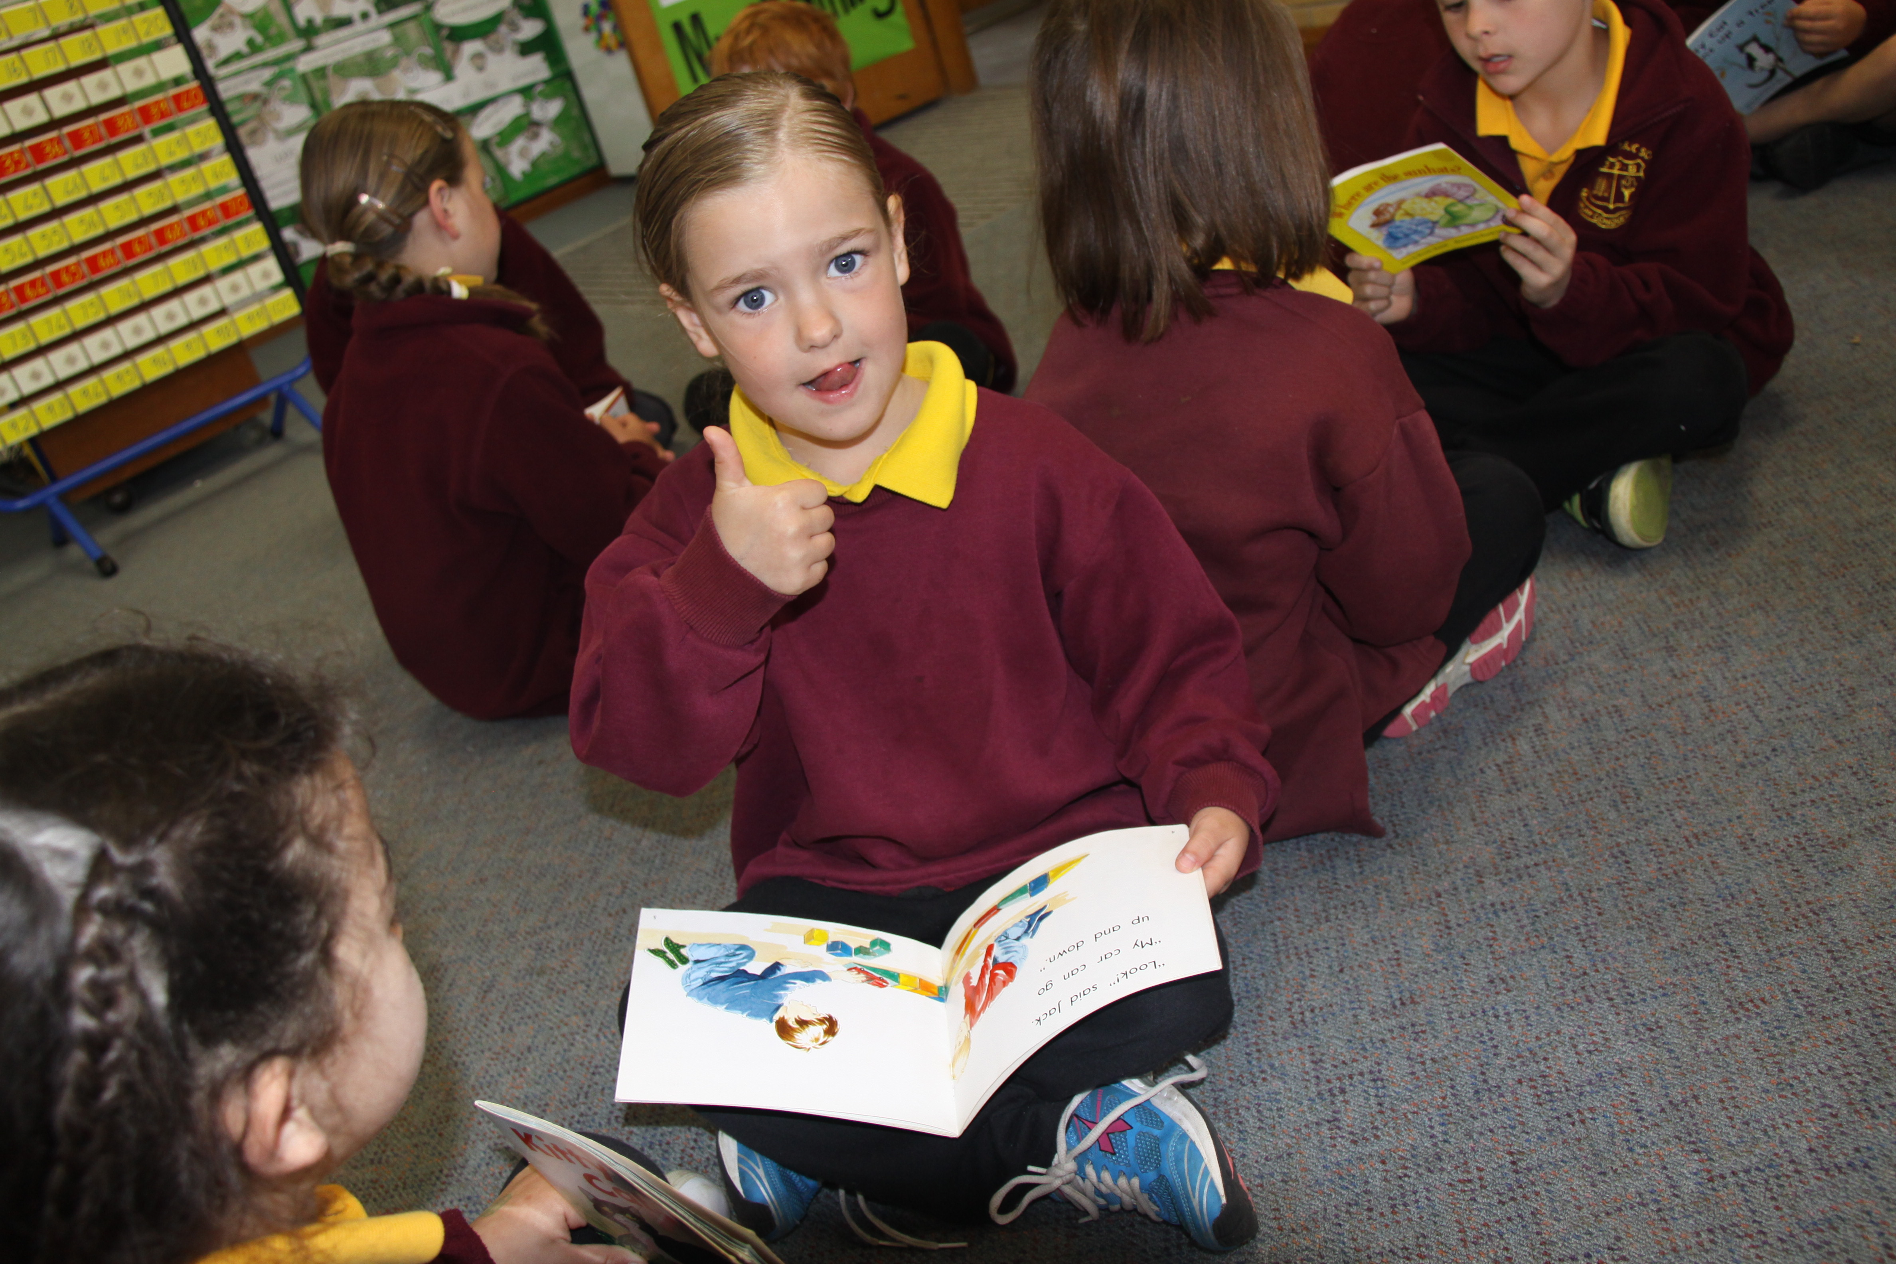
Tuesday 17th September 10.00am- 11.30am: Classroom experience and sport. Bring a hat and small recess snack.

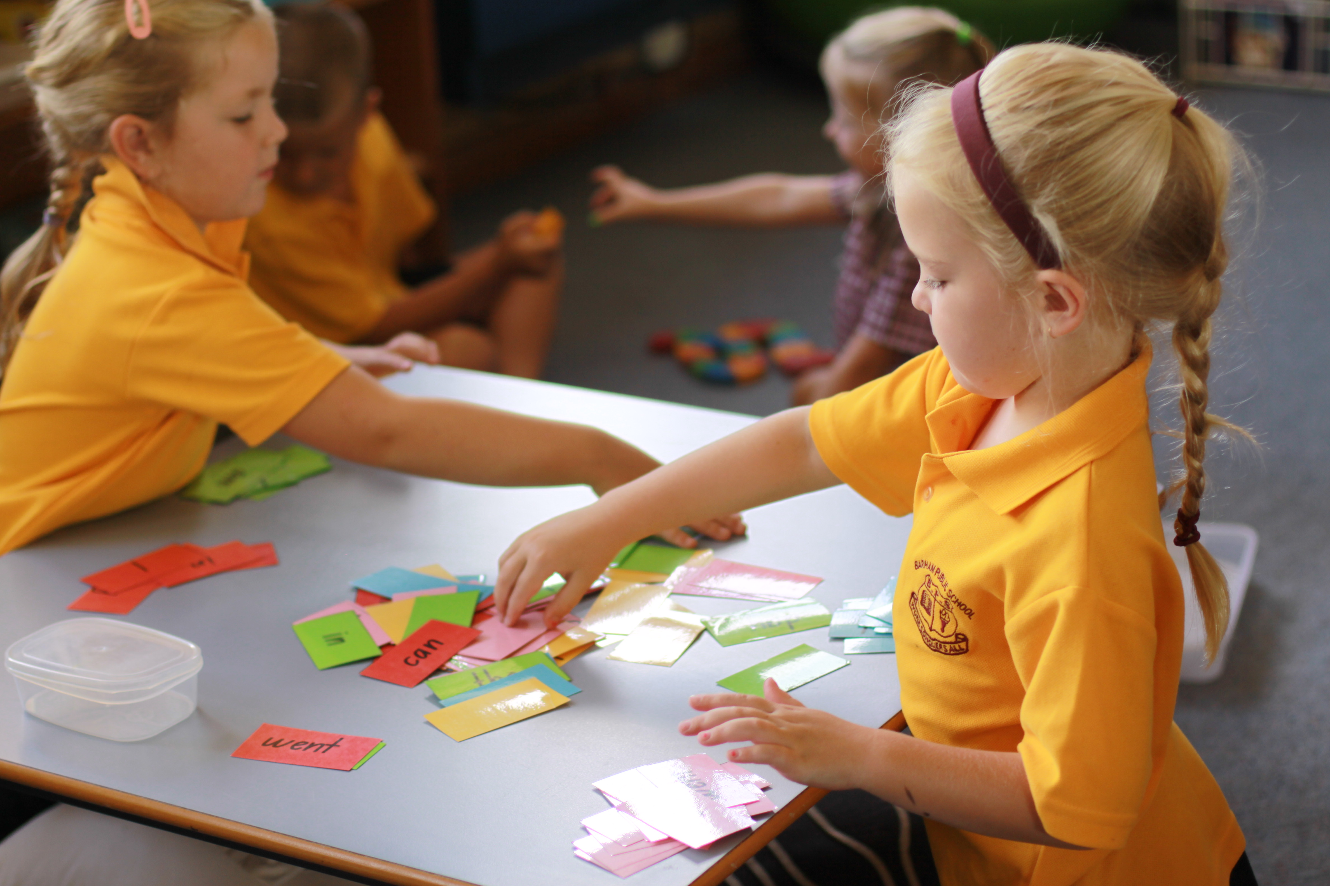

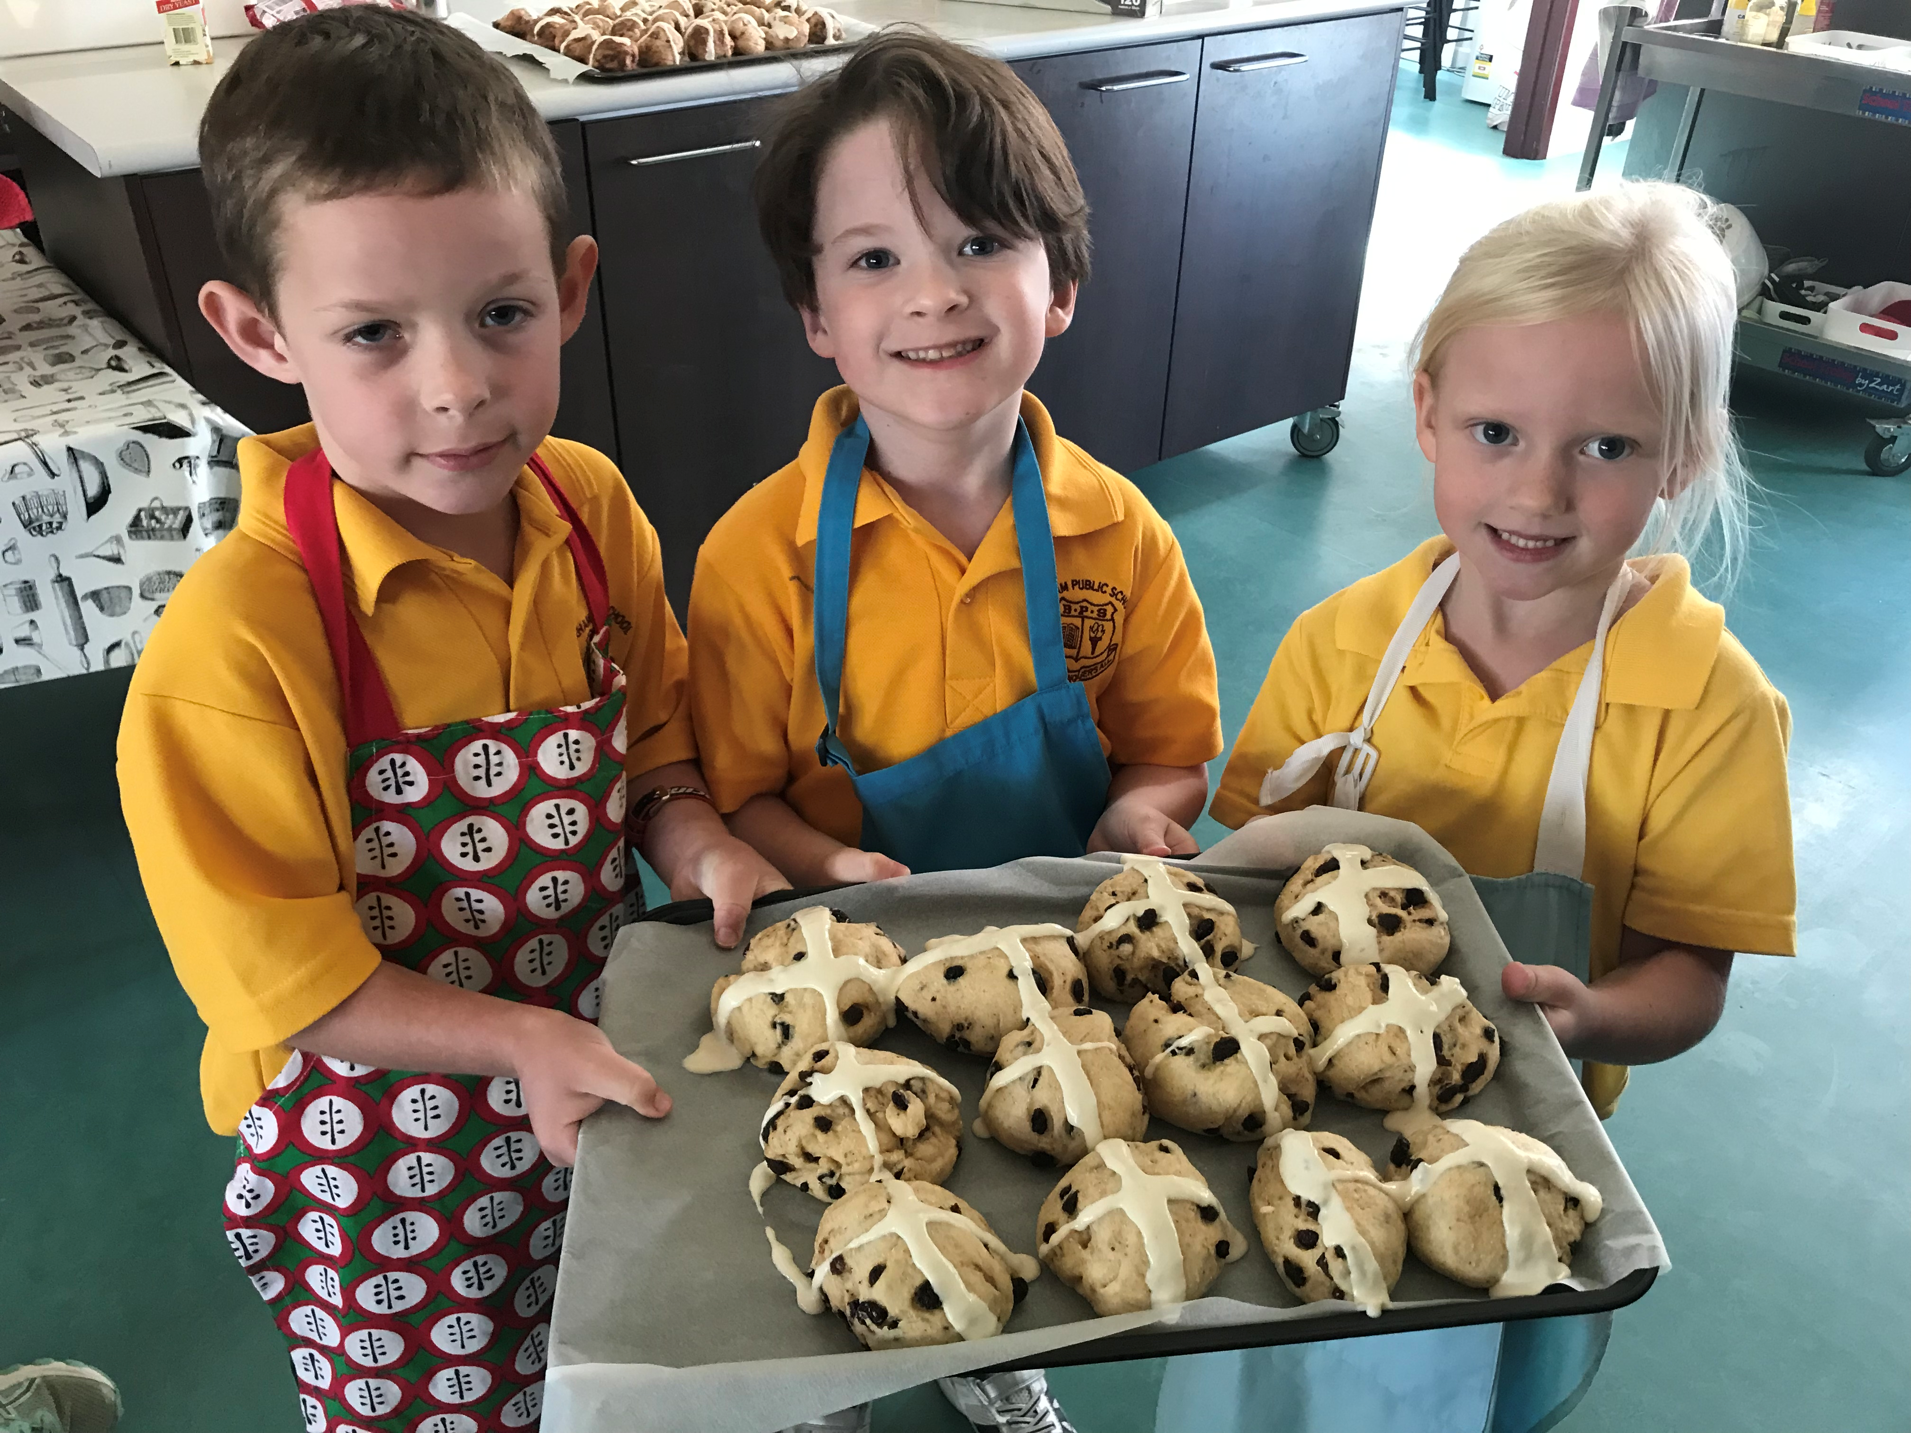

Friday 20th September 2pm: Whole School Assembly

Barham Public School
KINDERGARTEN TRANSITION PROGRAM

ORientation in TErm 4

Friday 8th November 2pm: Whole School Assembly

Friday 15th November 2pm: Orientation activity. Come along with your child to learn more about the school with an orienteering activity.

Friday 22nd November 8.50am – 11.30am : Drop your child off for a classroom literacy session and recess. Bring a hat, crunch and sip snack and recess packed in your school bag.

Friday 29th November 8.50am- 2pm: Drop your child off for a classroom literacy session, recess, numeracy session and lunch play. Bring a hat, crunch and sip snack, recess and lunch (packed school bag).

Friday 6th December 8.50am- 3pm: Drop your child off for a full day at school. Bring your packed school bag.

Monday 9th and Tuesday 10th December Drop your child off or send them on the bus for a full day at school. Bring your packed school bag.

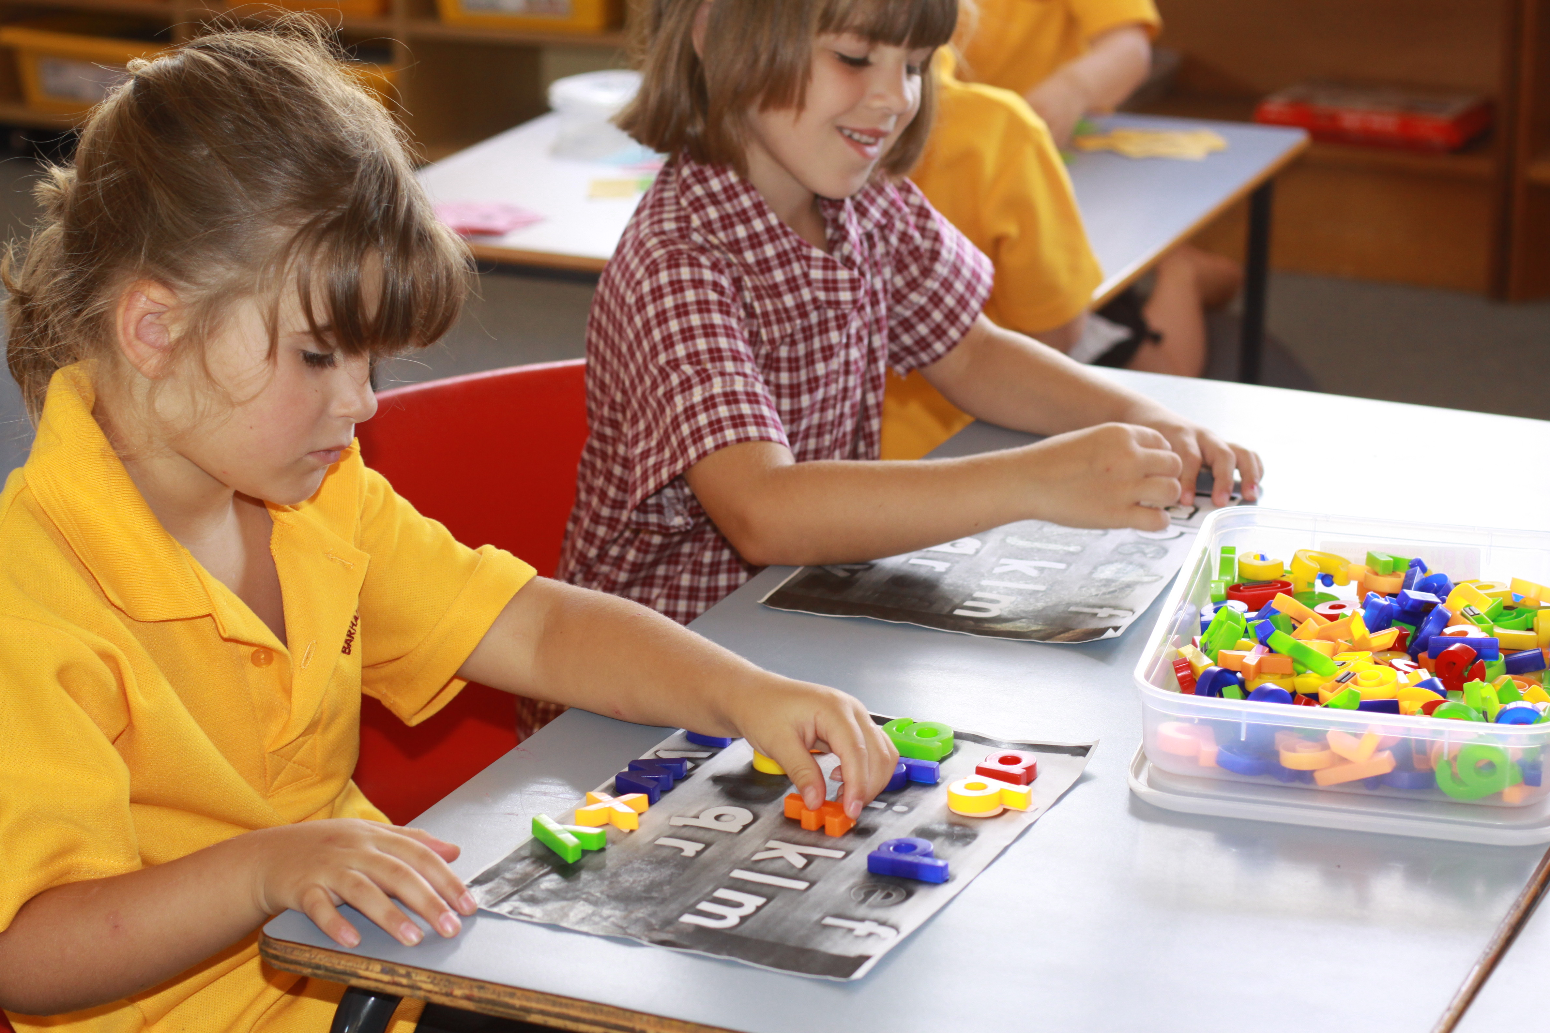

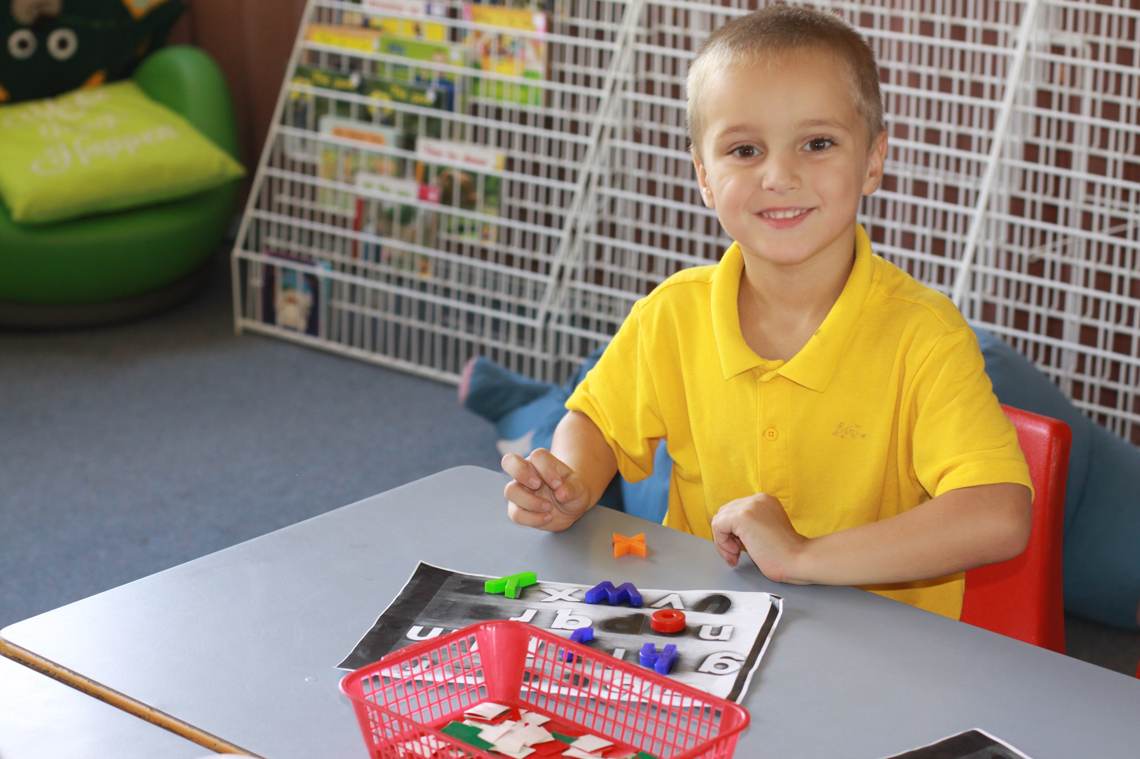

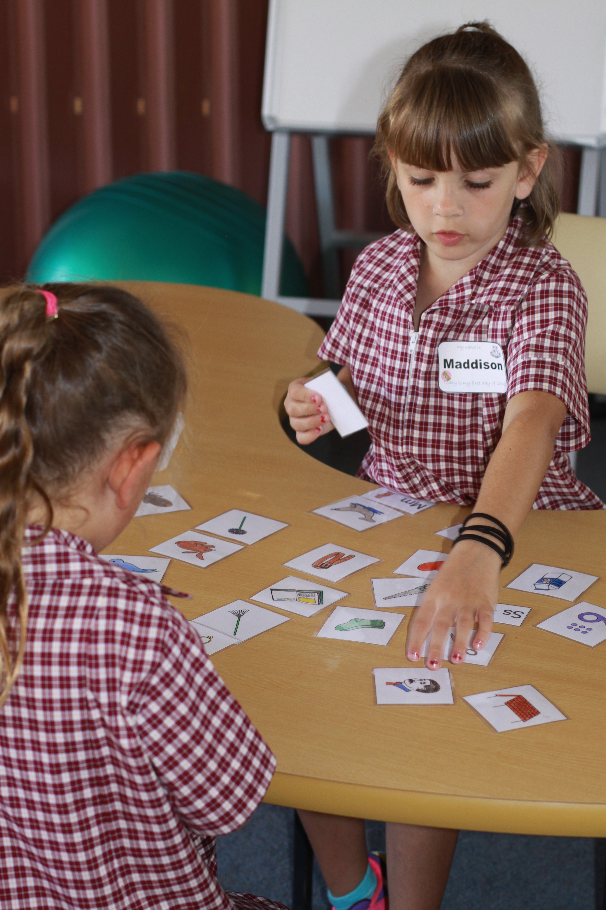

For children starting school in 2020 and their carers

Come along and experience some taster activities in our school together with your child. You will get to know some of the teachers and become familiar with some of the space and routines of school.

Contact the school for more information
03 545 32133

