Download the Sentral Parent App
The Sentral for Parents app allows you to monitor your child’s school journey simply and efficiently. You will find numerous smart features that help streamline your day. Receive messages and notifications, report absences and more. The Sentral for Parents app helps you stay connected and informed about your child’s education.
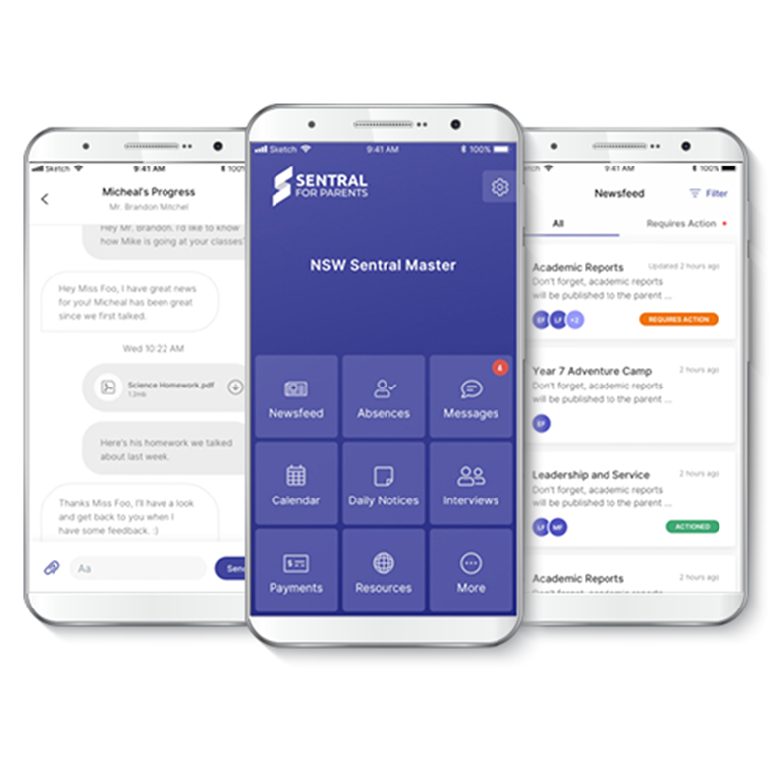
Download the app. Depending on your device, visit either the Apple App Store, or the Google Play Store.
- Search for your school in the search box.
- Tap Next.
- Tap Register here.
- Enter your details.
- Tap Create Account. This process also creates a Sentral Parent Portal account. You can use the login details created here to access the app, and the Parent Portal.
- You will receive a confirmation email.
- Click the link in the confirmation email to verify your details.
- Log in to the app.
- Use the access keys provided by your school to add your children to the app. Access keys can be added in the Settings menu.
- You will then see the Home Screen.
- View the QuickStart guide.
- You’re now ready to use the app.
Please contact the school if you need assistance with this process.

